BYLAWS OF
GREATER RAMSEY WATER DISTRICT

ARTICLE I

General Purposes

The purposes for which this District is formed, and the powers which it may exercise are set forth and pursuant to Chapter 61-35 of the North Dakota Century Code, and in general for the operation of a rural water distribution, treatment and sewer systems.

ARTICLE II
Name and Location
Section 1. The name of the District is the GREATER RAMSEY WATER DISTRICT. Section 2. The principal office of this District shall be located in the City of Devils Lake,
County of Ramsey, and State of North Dakota.

ARTICLE III
Seal
Section 1. The seal of the District, if used, shall have inscribed thereon the name of the District, the date of its organization, same being May 1, 2006 and the words, Greater Ramsey Water District.

Section 2. The secretary-treasurer of the District shall have custody of the seal.

Section 3. The seal may be used for causing it or a facsimile thereto to be impressed or affixed or reproduced or otherwise.

ARTICLE IV

Fiscal Year

The fiscal year of the District shall begin the 1st day of January in each year.

ARTICLE V

Membership

Section 1. A member means an owner of real property that is located within the District, the tenant of the real property, or another person acting for the owner with the owner’s written consent. A participating member means a member who has subscribed to and paid the established fee for at least one benefit unit in the District, in the manner provided by NDCC, Chapter 61-35 and Section VI of the Rules and Regulations of GRWD, and has an active account in good standing. If a tenant has an active account in good standing, but did not pay the membership fee, the owner shall be considered the member. A benefit unit means the fee each member pays, for each service that is planned to be connected to the District system, for the privilege of using the District’s facilities.

Section 2. Each participating member of the District is entitled to one vote for each benefit unit to which the member has subscribed, at all annual and special meetings of the District.
Section 3. Membership shall be transferable, but only under the conditions of Section XIV of the Rules and Regulations of the GRWD.
Section 4. Membership in the District shall be terminated under the conditions of Section XVIII of the Rules and Regulations of GRWD.

ARTICLE VI

Meetings of Members

Section 1. The annual meeting of the participating members of this District shall be held at its offices in the city of Devils Lake, County of Ramsey, State of North Dakota, at 7:00 o’clock p.m., on the 1st Tuesday in February of each year, but if a legal holiday, on the next business day following. The place, day, and time of the annual meeting may be changed to any other convenient place, day and time in the distribution area of the District by the board of directors giving notice thereof to each member not less than ten (10) days, nor more than forty-five (45) thirty (30) days in advance of the meeting. Publication of the notice shall be done pursuant to Section 3 below.

Section 2. Special meetings of the participating members may be called at any time by the action of the board of directors and such meetings must be called whenever a petition requesting such meeting is signed by at least five percent (5%) of the participating members and presented to the secretary-treasurer or to the board of directors. The purpose of every special meeting shall be stated in the notice thereof, and no business shall be transacted thereat except such as is specified in the notice.

Section 3. Written notice of the time, date and place of each annual meeting shall be

mailed to participating members, and notice of the annual meeting shall be published in the official newspapers of the counties served by the District, not less than ten nor more than forty- five thirty days before each meeting.

Section 4. A majority of those participating members present at a meeting shall constitute a quorum.

Section 5. Directors of the District shall be elected at the annual meeting of the members as provided in Article VII, Section 1. No cumulative voting shall be allowed.

Section 6. The order of business at the regular meetings and so far as possible at all other meetings shall be:
- Calling to order and proof of quorum.
- Proof of notice of meeting.
- Reading and action on any unapproved minutes.
- Reports of officers and committees.
- Approval of treasurer’s report.
- Election of directors.
- Unfinished business.
- New business.
- Adjournment.

ARTICLE VII

Directors and Officers

Section 1. The board of directors of this District shall consist of seven (7) members, all of whom shall be members of the District and reside in the area which the director will represent.
Nominees for a director position must file nomination by the published deadline. The nominating committee will verify qualifications and will forward to the election only qualified candidates having met the deadline. No additional nominations will be accepted. Each participating member seeking election to the board shall present a petition containing signatures of ten participating members. All petitions must be submitted to the secretary of the board at least forty-five days before the election. Any participating member who submits a petition must be added to the ballot, provided they reside in the appropriate district and qualify to serve as a director under the District’s bylaws. Members may cast their vote at the annual meeting or may vote in person at the District office during office hours beginning one week ahead of the annual meeting. Businesses may designate an authorized representative to cast a proxy vote on their behalf upon presentation of valid proxy statement. In the event of a tie vote, a flip of a coin will determine the successful nominee. Ward 1 shall have two (2) directors, Ward 2 shall have three (3) directors, and Ward 3 shall have two (2) directors from the areas as indicated on the attached map, “Exhibit A”. At each annual meeting, the members shall elect for a term of (3) three years the number of directors whose terms of office have expired. Each director shall hold office for the term elected and until successor has been elected and qualified.

Section 2. The board of directors shall meet immediately following the annual meeting of the members, and shall elect a president and vice president from among themselves and a secretary-treasurer who need not be a member of the board of directors, each of whom shall hold office until the next regular meeting and until the election and qualification of successor unless sooner removed by death, resignation or for cause. The board may also meet at other times it determines, or upon the call of the president or any two directors.

Section 3. If the office of any director becomes vacant by reason of death, resignation, retirement, disqualification or otherwise, a majority of the remaining directors, though less than a quorum shall by majority vote, appoint a successor who shall hold office for the unexpired term.
the vacancy will be filled for the unexpired term by appointment by the remaining directors until the next annual meeting of participating members, at which time the participating members shall elect a director for the unexpired term.

Section 4. A majority of the board of directors shall constitute a quorum at any meeting of the board. The affirmative vote of the majority of the directors at a meeting at which a quorum is present shall be the act of the board.

Section 5. Compensation of officers may be fixed at any regular or special meeting of the members of the corporation. Directors shall receive no compensation for their services as such, but are entitled to reasonable compensation to cover expenses of serving on the board.

ARTICLE VIII
Powers of Directors
Section 1. The board of directors shall have, and are hereby given, full power and authority in respect to the matters as hereinafter set forth to be exercised by resolution duly adopted by the board:
- To approve membership applications.
- To select and appoint all officers, agents or employees of the District, prescribe such duties and designate such powers as may not be inconsistent with these bylaws, fix their compensation and pay for faithful services.
- To borrow from any source, money, goods or services and to make and issue notes and other negotiable or non-negotiable instruments evidencing indebtedness of the District; to make and issue mortgages, deeds of trust, pledges of revenue, trust agreements, security agreements and financing statements, and other instruments evidencing a security interest in the assets of the District; and, to do every act and thing necessary to effectuate the same.
- To prescribe, adopt and amend, from time to time such equitable uniform rules and regulations as, in its discretion, may be deemed essential or convenient for the conduct of the business and affairs of the District and the guidance and control of its officers and employees, and to prescribe adequate penalties for the breach thereof.
- To order, at least once each year, an audit of the books and accounts of the District by a competent public auditor or accountant. The report prepared by such auditor or accountant shall be made available at the District office and posted electronically. A financial statement and current budget shall be submitted to the members of the District at the annual meeting. Copies of such audits and budgets shall be submitted to such parties as may be required by other agreements.
- To fix and alter the charges to be paid by each participating member for services rendered by the District to the member, including connection fees where such are deemed to be necessary by the directors, and to fix and alter the method of billing, time of payment, manner of connection, and penalties for late or nonpayment of the same. The board may establish one or more classes of users. All charges shall be uniform and nondiscriminating within each class of users.
- To require all officers, agents and employees charged with responsibility for the custody of any of the funds of the District to give adequate bonds, the cost thereof to be paid by the District, and it shall be mandatory upon the directors to so require.
- To select one or more banks to act as depositories of the funds of the District and to determine the manner of receiving, depositing, and disbursing the funds of the District and the form of checks and the person or persons by whom the same shall be signed, with the power to change such banks and the person or persons signing such checks and the form thereof at will.
- To levy assessments against the members of the District in such manner and upon such proportionate basis as the directors deem equitable, and to enforce collection of such assessments by the suspension of water services or other legal methods. The board of directors shall have the option to suspend the service of any member who has not paid such assessment within thirty (30) days from the date the assessment was due, provided the District must give the member at least fifteen (15) days written notice at the address of the member on the books of the District of its intention to suspend such service if the assessment is not paid. Upon payment of such assessments, any penalties applicable thereto, and a reconnection charge, if one is in effect, service will be promptly restored to such member. This procedure does not waive any other statutory or legal right or remedy available to the District for termination, collection, and/or prosecution for unauthorized usage.
- The duties stated above are not inclusive, but shall include all powers granted to the board pursuant to North Dakota Century Code, Section 61-35-12, and Chapters 61-35 and 10- 26, in general.

ARTICLE IX

Duties of Officers

Section 1. Duties of the President. The president shall preside over all meetings of the District and the board of directors, call special meetings of the board of directors, perform all acts and duties usually performed by an executive and presiding officer, and sign all water user agreements and such other papers of the District as authorized or directed to sign by the board of directors, provided the board of directors may authorize any person to sign any or all checks, contracts and other instruments in writing on behalf of the District. The president shall perform such other duties as may be prescribed by the board of directors.
Section 2. Duties of the Vice-President. In the absence or disability of the president, the vice-president shall perform the duties of the president; provided, however, that in case of the death, resignation or disability of the president, the board of directors may declare the office vacant and elect a successor.
Section 3. Duties of the Secretary-Treasurer. The secretary-treasurer shall keep a complete record of all meetings of the District and of the board of directors and shall have general charge and supervision of the books and records of the District. The secretary- treasurer shall attest the president’s signature on papers pertaining to the District unless otherwise directed by the board of directors. The secretary-treasurer shall serve, mail, or deliver all notices required by the law and by these bylaws and shall make a full report of all matters and business pertaining to this office to the participating members at the annual meeting or at such other time or times as the board of directors may require. The secretary-treasurer shall keep the District seal and membership records of the District, complete and attest all certificates

issued and affix said District seal to all papers requiring seal. The secretary-treasurer shall keep a proper membership record, showing the name of each member of the District. The secretary- treasurer shall make all reports required by law and shall perform such other duties as may be required by the District or the board of directors. Upon the election of a successor, the secretary-treasurer shall turn over all books and other property belonging to the District. The secretary-treasurer shall also perform such duties with respect to the finances of the District as may be prescribed by the board of directors.

ARTICLE X

Amendments

These bylaws may be amended at any annual or special meeting of the participating members of the district. However, the bylaws must provide:
- For an annual meeting of participating members each year after the year of organization of the District and for mailing of written notice of the time and place of each annual meeting to each participating member and publication of the notice in the official newspaper of the county or counties served by the district not less than ten nor more than forty-five days before each meeting.
- That each participating member of the District is entitled to one vote at all annual and special meetings of the District for each benefit unit to which the member has subscribed.

Furthermore, during any period in which the District has indebtedness held or guaranteed by lenders, the participating members shall not have the power to change the purposes of the District so as to decrease its rights and powers under the laws of North Dakota, or to waive any requirement of bond of other provision for the safety and security of the property and funds of the District or its members, or so to amend the bylaws as to effect a fundamental change in the policies of the District without the prior written approval of the lenders, or other lender similar thereto.

Amended this 4th day of February, 2025.

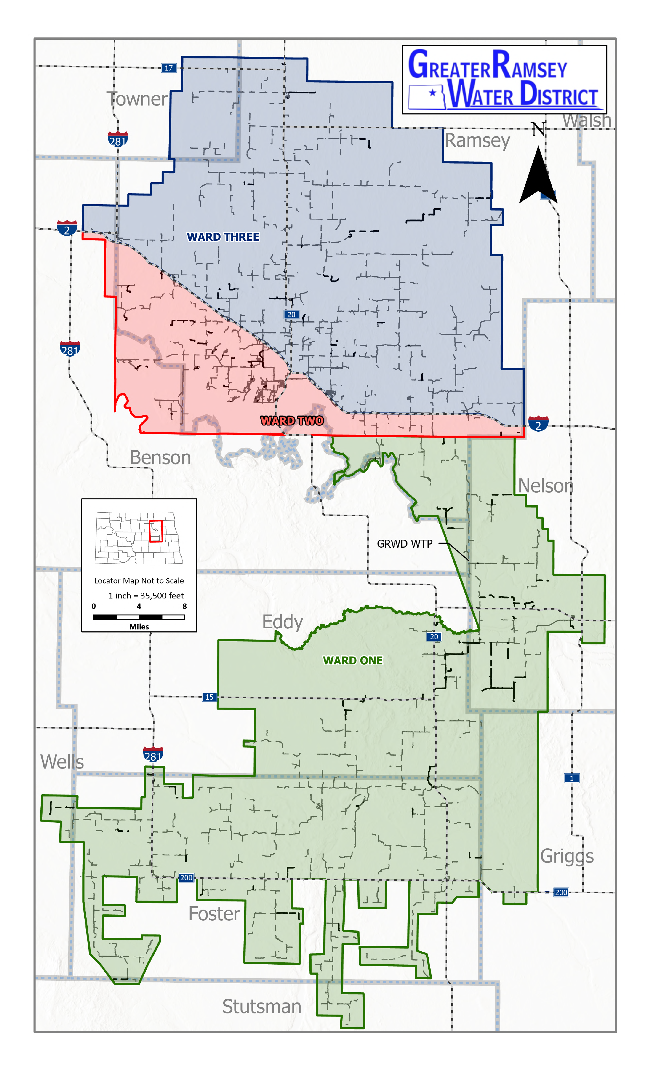
EXHIBIT A

